**LINUX COMMAND**

1. Ls

Running **ls command** with no option list files and directories in a bare format where we won’t be able to view details like file types, size, modified date and time, permission and links, etc.



1. Ls -l

**ls -l** shows file or directory, size, modified date and time, file or folder name and owner of the file, and its permission.

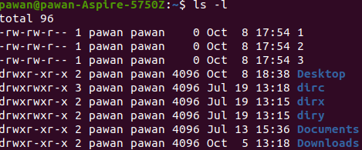

1. Ls -a

List all files including hidden files starting with ‘.‘

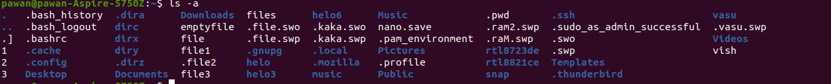

1. ls -lh

With a combination of **-lh** option, shows sizes in a human-readable format

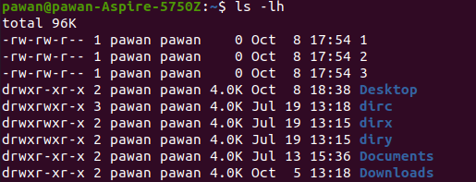

1. Ls -f

Using the **-F** option with the **ls** command will add the '/' character at the end of each directory.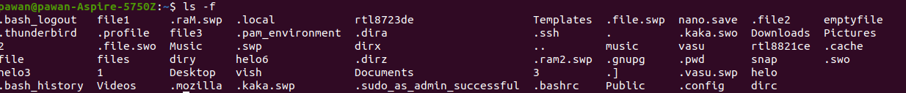

1. Ls -r

The following command with the **ls -r** option display files and directories in reverse order.



1. Ls -ltr

A combination of **-ltr** will show the latest modification file or directory date as last.

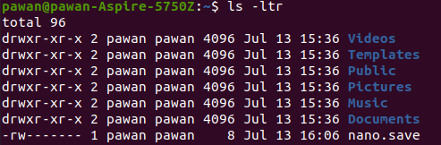

1. **ls -t :** to sort by date and time.
2. ls -x : to sort by extension name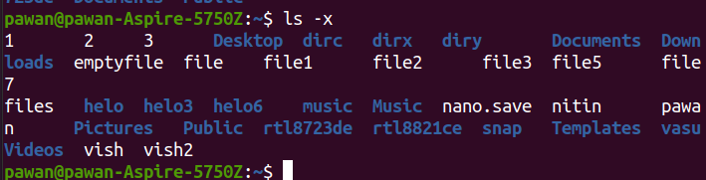
3. Pwd

Print working directory command in Linux



1. **Top**

**View active processes live with their system usage**

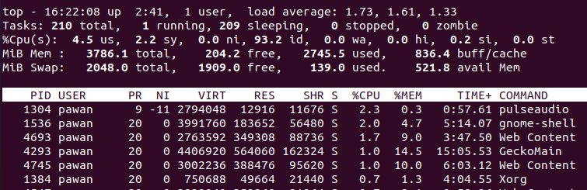

1. **tail To show last 10 lines from the bottom of a file**

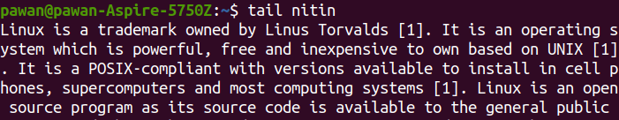

1. **tail -n 2**

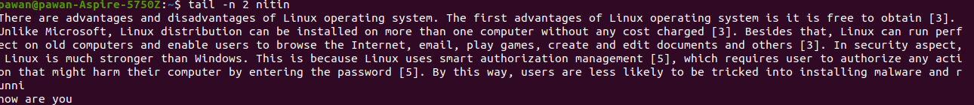

1. **tail -c**



1. **Whoami** :- to show the current user name



1. **Cat**

Used to display the contents of the file as named

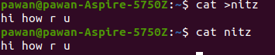

1. **cat file file2 > file4**

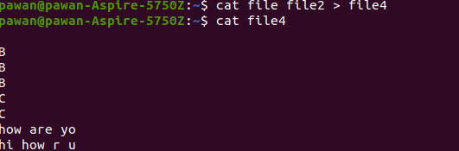

1. **mkdir** :- to create the directory

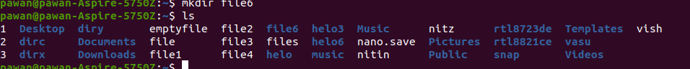

1. mkdir file6/file7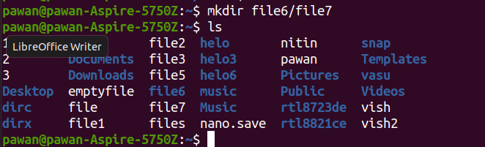
2. mkdir -p file6/file61/file7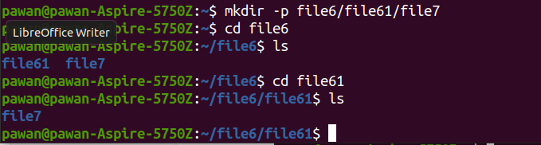
3. **rm** :- to remove the file

The rm command in Linux helps you delete files and directories.



1. **cp** :- to copy the file

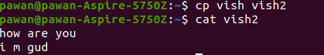

1. **mv**

Used to transfer a file from a given directory to a different directory. Used to rename a file to a different name as specified.

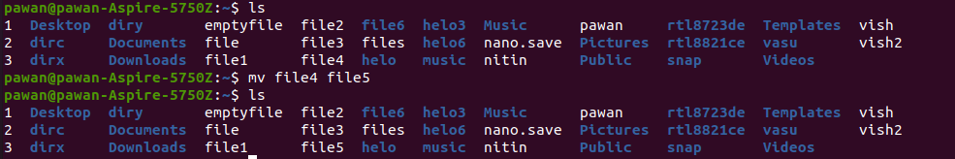

1. **touch**

### This command is used to create a new file without any content inside it.



1. Touch command is also used to create multiple file at a time.

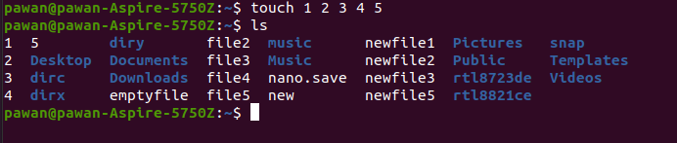

1. **stat command gives information about the file and filesystem.**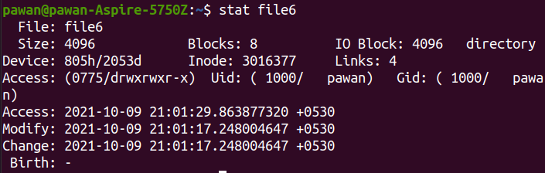
2. **Man** This command is used to display the documentation on the ‘ls’ command in Linux.

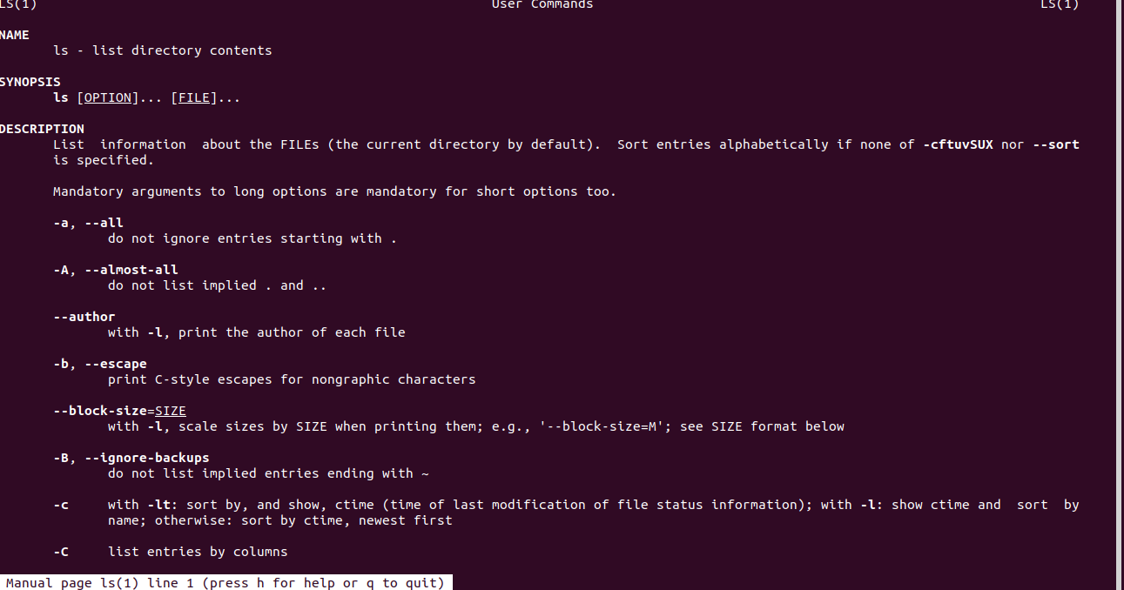

1. **cd**

This command is used to ‘change directory’



1. cd .. - to move backward from one directory 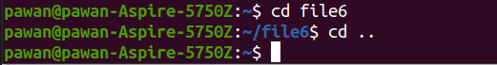
2. cd \ - to close all directory 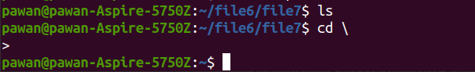
3. clear :- to clear the page 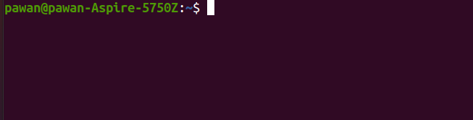
4. **echo**

The echo command in Linux simply displays a line of text/string which is passed in as an argument.



1. **rmdir**

The rmdir command in Linux only allows you to delete empty directories. So if a directory has some files/folders inside it, rmdir will display an error.

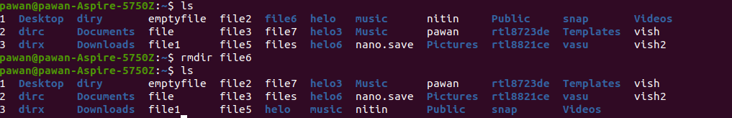

1. **tree**

The tree command in Linux can be used to list out the contents of directories in a tree-like fashion



1. **history**

The history command in Linux is used to view a history of all the commands previously executed inside the bash terminal. The total number of executed commands will vary from one system to another.

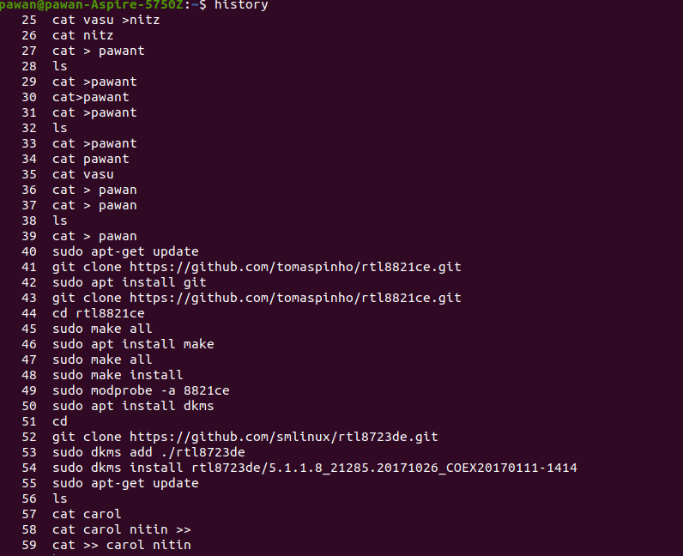

1. **head**

The head command in Linux prints the first N lines of a given file content.

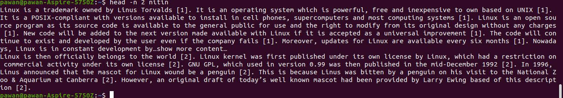

1. head -n 2 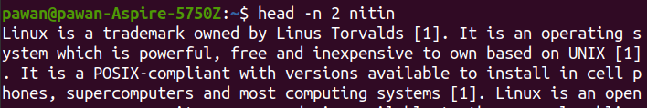
2. head -c 20 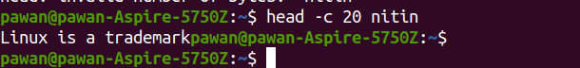
3. **wc**

The wc command in Linux expands to 'word count'. It is used to display the number of lines, words, characters, and bytes corresponding to any file mentioned in the arguments.



1. wc -w 
2. wc -l   
   
3. wc -c  
   
4. **Vi command:-** it is a programmer text editor.

**Note:- :w = to save   
 :wq = to save and quit**

**:q = quit**

**:q! = force quit and no save**

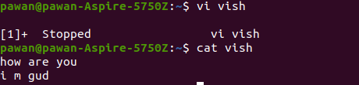

1. **lsblk** :- to display details about block devices

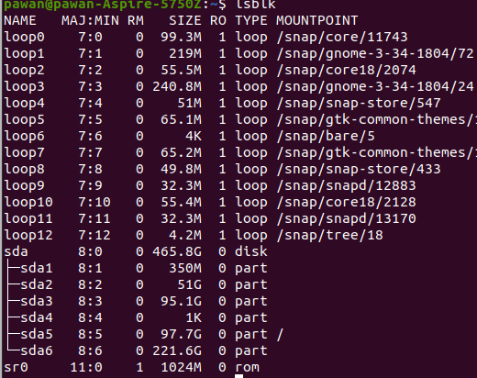

1. df to display the disk space used in the file system.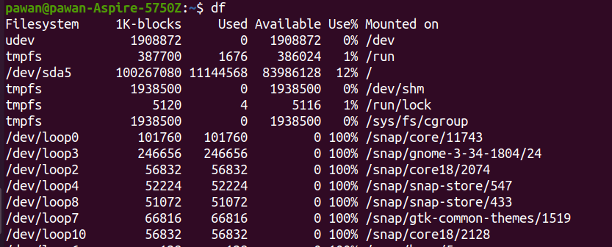
2. ps -au to get information about the processes running within your system.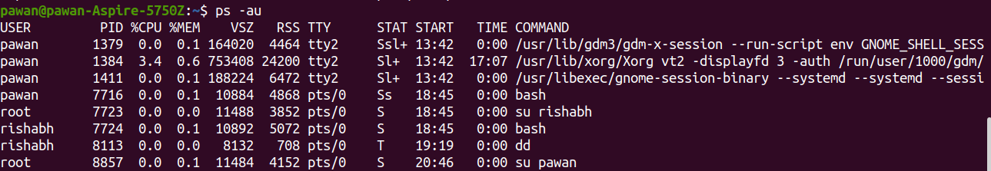

**Permission numbers are:**

* **0 = ---**
* **1 = --x**
* **2 = -w-**
* **3 = -wx**
* **4 = r-**
* **5 = r-x**
* **6 = rw-**
* **7 = rwx**

47. **chmod 777 folder name** / **file name** will give read, write and execute permissions for everyone.

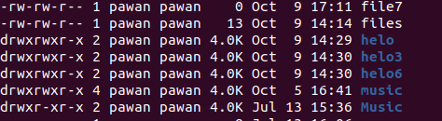

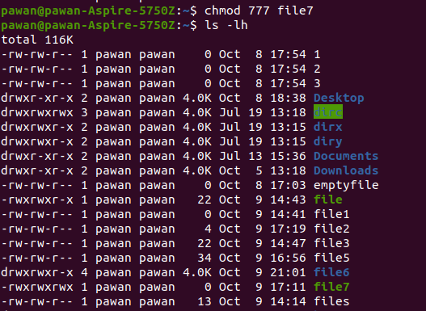

48. **Chmod 775 folder name / file name .** user and group full permission and other permission only read and execute.

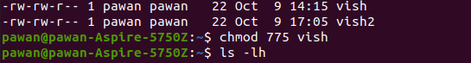

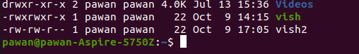

49. **Chmod 555 folder name / file name** . will not permission write everyone





50. **Chmod 740 folder name / file name .** user full permission access and group only write and other not access any permission.





51. **Chmod 751 folder name / file name.** User full permission access and group read and execute and other only execute permission





52. **Chmod 700 folder name / file name.** Only user full access permission and group and other not access any permission





53. **Chmod 744 folder name / file name.** User access full permission and group and other only write permission

 

54.**Chmod 755 folder name / file name.** User access full permission and group and other only write and execute permission

 

55. **Chmod 711 folder name / file name.** user can do anything and group and others can only execute





56. **Chmod 644 folder name / file name.** User can read and write and group and others can only read





57. **Chmod 400 folder name / file name.**  User only read and group and other not access any permission





58. **Chmod 200 folder name / file name.** User only right and group and other not access any permission





59. **Chmod 020 folder name / file name.** User and other not access any permission only group write permission access





60. **Chmod 004 folder name / file name.** User and group not access any permission and other only read permission access





61. **Chmod 001 folder name / file name.** User and group not access any permission and other only execute permission access





62. **Chmod 040 folder name / file name.** User and other not access any permission and only group read permission access

 

63. **Chmod 100 folder name / file name.** User only execute and group and other not access any permission





64. **Chmod 010 folder name / file name.** User and other not access any permission and only group execute permission access





65. **The sudo apt-get update command** is used to download package information from all configured sources.

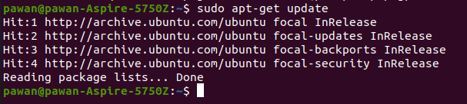

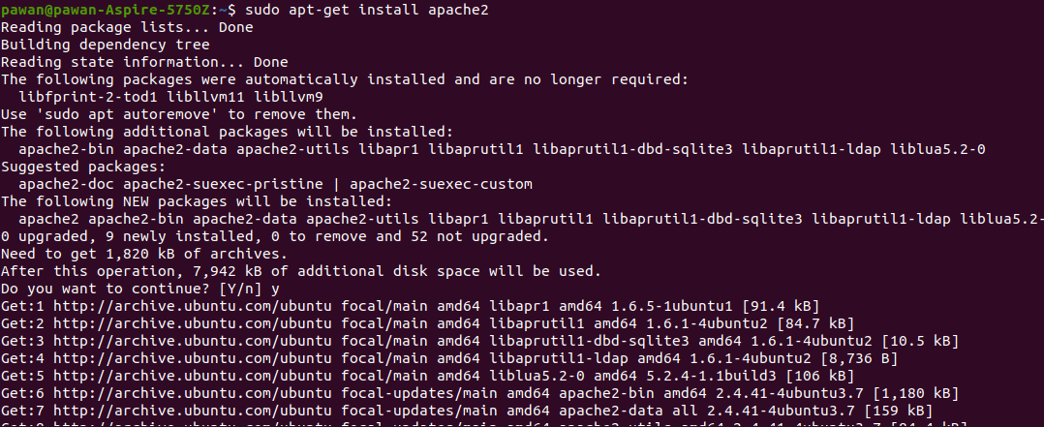

67. **The sudo apt-get remove** {package-name} .This command used for remove package .

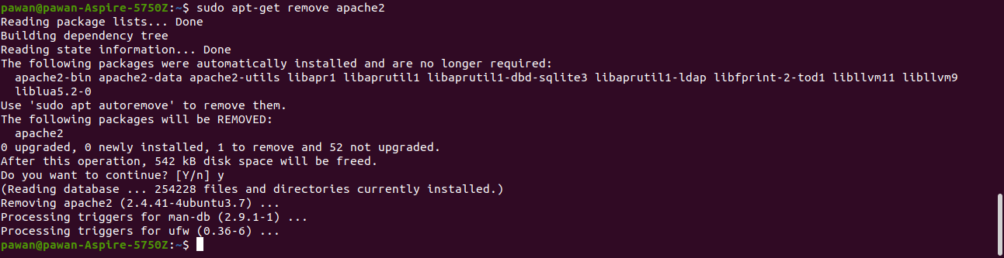

68. **The sudo apt-cache search** {package-name} : This command used for search package names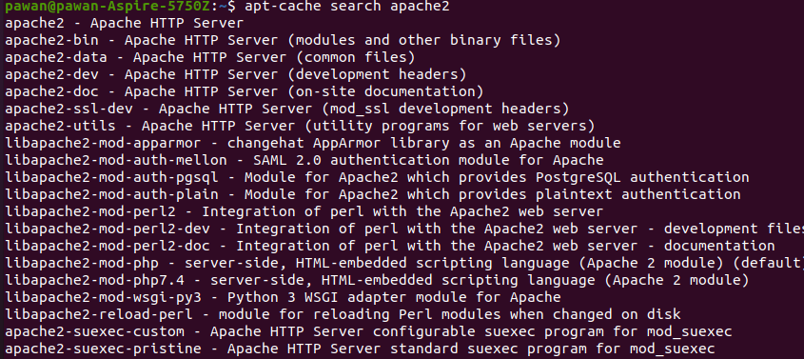

69. **Create new user command :**

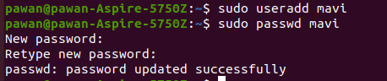

**70. Delete user command :**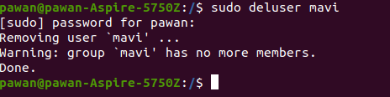

**71.** **Switch user command :**

**72. To give root user permission: **

**73. To check apache2 status :**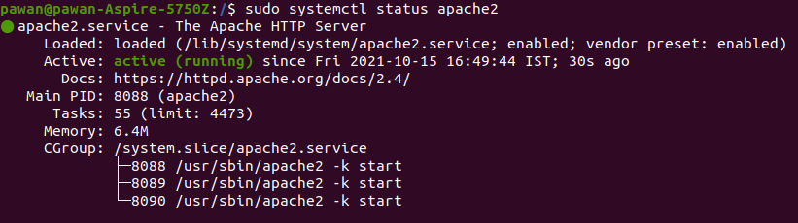

**74. To restart apache2 : **

**75. To stop apache2 :**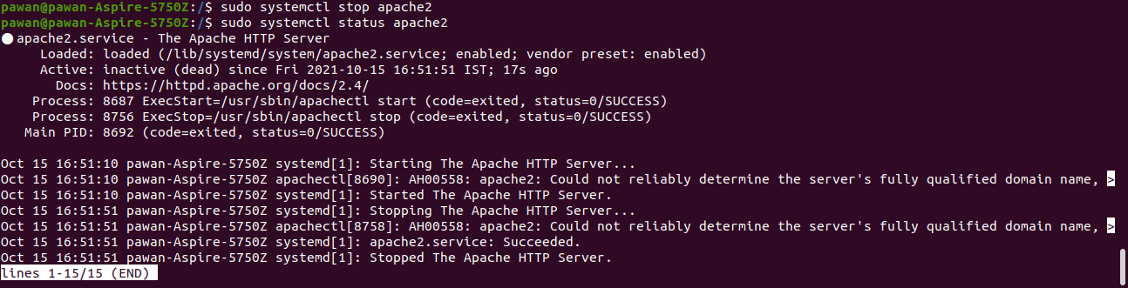

**76. To start apache2:** 